**East West University**

**Project Report**

**Semester:** Summer-2024

**Course Title:** Electrical Circuits **Course Code:** CSE209

**Sec:** 01

**Group No: 07**

**Group Members:**

|  |  |
| --- | --- |
| **Student Name** | **Student Id** |
| **Shiekh Sarafat Hossain** | **2022-3-60-109** |
| **Rijia Parveen Raya** | **2022-3-60-192** |
| **Esrat Jerin** | **2022-3-60-218** |
| **Nadira Akter** | **2022-3-60-220** |
|  |  |

**Submitted by-**

Name: Sheikh Sarafat Hossain

Id: 2022-3-60-109

**Submitted to-**

Dr. Sarwar Jahan

Associate Professor

Department of Computer Science & Engineering

East West University

**Date of Submission: 17-September-2024**

**A simple DC circuit for Traffic Signal System**

**Introduction**

Traffic control systems are vital for managing vehicles at intersections of 2, 3, or 4 roads, where signals regulate the flow of traffic. A typical traffic signal consists of three lights—Red, Yellow, and Green. Each road is allowed to pass when the green light is on and is prohibited when the red light is on. The yellow light is a transition signal between the red and green lights. This project aims to construct a simple DC circuit to replicate a manually controlled traffic signal system.

**Circuit Diagram**

**Problem Statement**

The project focuses on designing and simulating a basic traffic signal circuit that uses LEDs to represent traffic lights (Red, Yellow, Green). The circuit is controlled manually using push switches, which will allow toggling between the traffic lights for different roads at an intersection.

**Circuit Design**

The circuit diagram is composed of the following components:

9V DC Power Source: To power the circuit.

Three Push Switches: Used to control the LEDs. Two switches manage the Red and Green LEDs for two streets, while the third switch handles the Yellow LED.

270Ω Resistors: These resistors are placed in series with the LEDs to limit current and prevent damage.

LEDs: Red, Yellow, and Green LEDs are used to simulate the traffic lights at the intersection.

Operation:

Red Lights: The first switch activates or deactivates red lights on two opposite streets.

Green Lights: The second switch is used for controlling green lights, like the red lights.

Yellow Lights: The third switch toggles the yellow lights, which come on for a few seconds to indicate a transition from red to green or vice versa.

**Simulation**

The designed circuit was simulated using PSpice, an electrical circuit simulator, to verify its functionality before physical construction. Below are the results of the simulation:

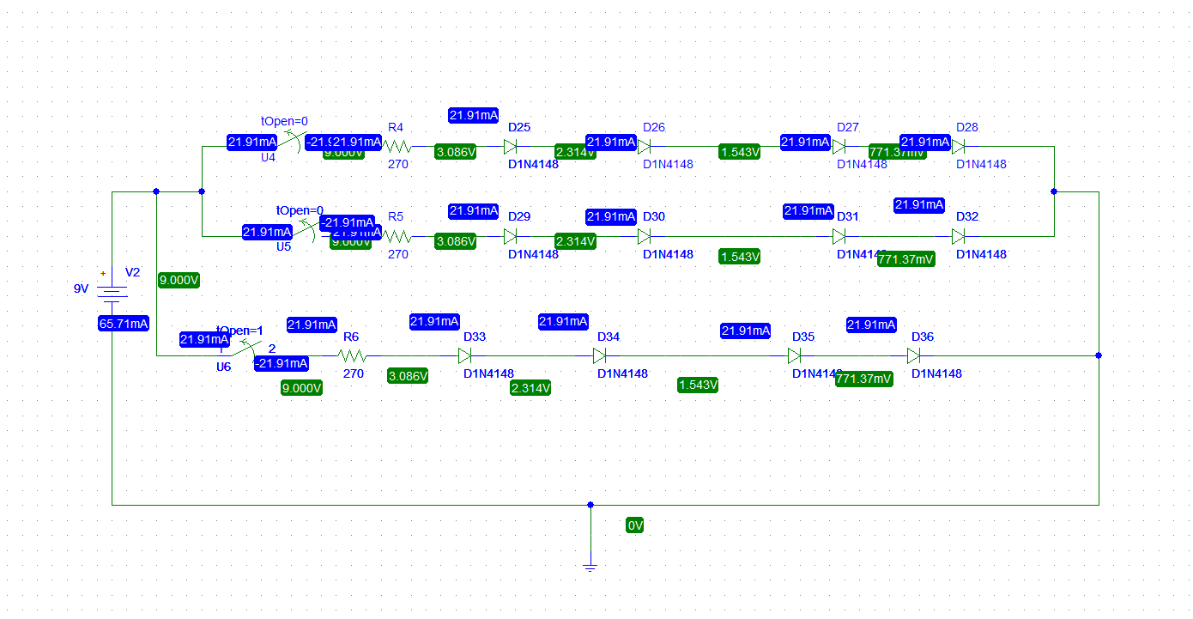

This is a circuit with diodes and resistors, operating from a 9V DC voltage source, with current and voltage values provided at different points. Here's an explanation of the circuit's functionality:

**Voltage Source**: The circuit is powered by a 9V battery or voltage source (V2), which provides 9V to the network of components.

**Current Flow**: The current in each branch of the circuit is **21.91 mA**. The diodes (1N4148) and resistors are connected in such a way that they limit the current and voltage drop across various points.

**Components and Functionality:**

1. **Resistors (R4, R5, R6)**: Each resistor has a value of **270 ohms** and limits the current in each branch. The current through the resistors is **21.91 mA**, which is consistent throughout the circuit.
   * The voltage drop across each resistor is around **3.086V**, as shown in the labels.
2. **Diodes (D25, D26, D29, etc.)**:
   * The diodes are standard **1N4148** silicon diodes, which have a forward voltage drop of about **0.7V** when conducting.
   * The diodes are connected in series with the resistors. As the current flows through the resistors, it encounters these diodes, and each diode has a voltage drop of around **0.7V**.

**Branch Behavior:**

* **Upper Branch (R4, D25, D26, D27)**:
* The current flows through resistor R4, resulting in a voltage drop of **3.086V**.
  + After R4, the current flows through diodes D25, D26, D27, and D28.
  + Each diode has a voltage drop:
    - D25: **2.314V**
    - D26: **1.543V**
    - D27: **771.37mV**
  + These drops are cumulative as the current flows through the series of diodes.
* **Middle Branch (R5, D29, D30, D31)**:
  + This branch is identical in behavior to the upper branch. The resistors and diodes behave in the same way, with similar voltage drops.
* **Lower Branch (R6, D33, D34, D35)**:
  + The same current flows through resistor R6, resulting in the same **3.086V** drop.
  + Diodes D33, D34, and D35 behave like those in the other branches, showing cumulative voltage drops as the current flows through them.

**Diode Function:**

* The diodes in the circuit ensure that current flows in one direction only (forward bias). The voltage drops across the diodes are typical for **1N4148** diodes, which have a forward voltage of about **0.7V** when conducting current.

**Note**: Due to the limitations of the student version of PSpice, which does not support LED components, diodes were used as an alternative in the simulation.

**Conclusion**

The project successfully demonstrated the design and construction of a simple DC traffic signal circuit. The simulation was error-free, and the physical construction worked as expected, with accurate transitions between the lights. The project provided valuable hands-on experience with circuit design, simulation, and construction using PSpice and a breadboard.